ORIGINAL RESEARCH (FULL-LENGTH ARTICLE)
Comparative Physicochemical and Ultrastructural Characterization of Extracellular Vesicle-Enriched Preparations from Blood, Urine, and Honey
ABSTRACT
Background: Extracellular vesicle (EV)-enriched preparations can vary substantially across biological matrices, complicating cross-source comparison. This study compared preparations from blood, urine, and honey using a harmonized isolation and characterization workflow.
Methods: Blood from five donors (90 mL), urine from three donors (150 mL), and three honey batches (150 mL) underwent differential centrifugation, 0.22-µm filtration, and ultracentrifugation at 100,000 × g. Source-level pooled preparations were assessed by dynamic light scattering, electrophoretic light scattering, Bradford assay, anti-CD9 bead capture with anti-human CD81 detection, and cryoelectron microscopy.
Results: Intensity-weighted Z-average ranges were 47.3-60.1 nm for blood, 111.9-324.9 nm for urine, and 211.3-614.1 nm for honey, indicating greater heterogeneity in urine and honey. Apparent zeta potentials measured in high-conductivity buffer were near neutral and were considered buffer limited. Protein concentrations were 664.4, 187.7, and 181.6 µg/mL, respectively. CD81-positive bead events were 17.7% for blood, 20.0% for urine, and 0.3% for honey; the honey result was not considered an appropriate identity test because the assay used anti-human antibodies. Cryoelectron microscopy showed membrane-enclosed vesicular structures in all preparations.
Conclusion: The workflow recovered vesicle-enriched material from all three matrices, but analytical readouts were strongly matrix and assay dependent. Single-particle quantification, expanded EV and contaminant-marker panels, source-appropriate honey markers, and biological replication are required before functional or therapeutic inferences.
MeSH Headings: Blood; Cryoelectron Microscopy; Extracellular Vesicles; Honey; Urine
Abbreviations: BSA, bovine serum albumin; cryo-EM, cryoelectron microscopy; DLS, dynamic light scattering; DPBS, Dulbecco phosphate-buffered saline; EV, extracellular vesicle; FCM, honey preparation tube code; FCD, blood preparation tube code; FCU, urine preparation tube code; NTA, nanoparticle tracking analysis; PBS, phosphate-buffered saline; PDI, polydispersity index; PE, phycoerythrin; PES, polyethersulfone; RCF, relative centrifugal force; UNS, unstained control; uEV, urinary extracellular vesicle; VLN, vesicle-like nanoparticle.

1. INTRODUCTION
Extracellular vesicles (EVs) are membrane-limited particles released by cells and capable of transporting proteins, lipids, and nucleic acids between cells. Because biogenesis was not directly established in many experimental settings, current recommendations favor operational terms based on the source, isolation method, and measured characteristics rather than assigning exosome or microvesicle identity solely from size [1]. EVs are being investigated as biomarkers and as biological delivery platforms because of their cargo-carrying capacity, biocompatibility, and ability to participate in intercellular communication [2-4].
Blood is a widely studied EV source but is obtained invasively and contains abundant soluble proteins and lipoproteins that can co-isolate with vesicles [1,5]. Urine offers a non-invasive source for EV research and biomarker discovery, although urinary composition and pre-analytical handling can affect recovery [7-9]. Honey and other bee products have also been reported to contain membrane-enclosed vesicle-like nanoparticles with biological activity [6,10]. These matrices differ markedly in viscosity, protein background, ionic composition, and species origin; therefore, an analytical method suitable for one matrix may not be directly transferable to another.
Direct comparisons across blood, urine, and honey using a harmonized workflow remain limited. The present descriptive laboratory study compared EV-enriched preparations from these three matrices using differential centrifugation, membrane filtration, and ultracentrifugation, followed by intensity-weighted particle sizing, apparent zeta-potential measurement, total-protein quantification, bead-based CD81 detection, and cryoelectron microscopy. The objective was to establish a matrix-aware baseline and to identify analytical limitations that should guide subsequent quantitative and functional studies.

2. MATERIALS AND METHODS

2.1 Study design and ethical approval
This was a descriptive comparative laboratory study of EV-enriched preparations obtained from human blood, human urine, and honey. Human sampling was approved by the Research Ethics Committee, Faculty of Medicine and Health Sciences, Universitas Kristen Krida Wacana (ethical code 1939/SLKE/IM/UKKW/FKIK/KEPK/III/2025). All procedures involving human participants were conducted in accordance with the Declaration of Helsinki, and written informed consent was obtained before sample collection.

2.2 Source materials and sample collection

2.2.1 Blood
Venous blood was collected from five healthy adults without acute or chronic disease, active infection, or medication use expected to substantially affect plasma composition. A total of 90 mL was collected into K2-EDTA tubes. Samples were gently inverted and processed within 2 h. Whole blood was centrifuged at 2,000 × g for 15 min at room temperature to obtain platelet-poor plasma [5].

2.2.2 Urine
First-morning midstream urine was obtained from three healthy adults without known kidney or urinary tract disease, active urinary tract infection, pregnancy, or nephrotoxic medication use. Each donor provided approximately 50 mL, for a total of 150 mL. Donors were instructed to avoid strenuous exercise and to fast overnight before collection. Urine was collected into sterile polypropylene containers containing 4.2 mL of a commercial protease-inhibitor cocktail. Color, turbidity, pH, and specific gravity were assessed before processing [7-9].

2.2.3 Honey
Three independent batches of fresh, unprocessed wild forest honey produced by Apis dorsata were supplied by Beezee Honey Indonesia. The material originated from Central Java, Indonesia, and a total of 150 mL was analyzed. Samples were transported cooled and protected from light and were stored at 4 °C before processing [6,10].

2.3 Enrichment workflow
Low- and medium-speed centrifugation was performed using a Velocity 18R Pro refrigerated centrifuge. Ultracentrifugation was performed using an Optima XPN-100 ultracentrifuge with an SW-41 Ti swinging-bucket rotor (k-factor 124; Beckman Coulter, USA). Relative centrifugal force is reported throughout. After source-specific isolation, aliquots from donors or batches within each matrix were combined to generate one pooled preparation per source for downstream characterization. Final resuspension volumes were recorded as operational processing volumes and were not interpreted as particle yield.

2.3.1 Blood-derived preparation
Platelet-poor plasma was centrifuged at 2,500-3,000 × g for 10 min at 4 °C to remove residual platelets and debris. The supernatant was diluted with sterile PBS (pH 7.4), passed through a 0.22-µm low-protein-binding PES filter, and ultracentrifuged at 100,000 × g for 90 min at 4 °C. The pellet was rinsed with PBS and resuspended in a recorded working volume of PBS or DPBS. Aliquots were stored at -20 °C for short-term use or -80 °C for longer-term storage.

2.3.2 Urine-derived preparation
Urine was centrifuged sequentially at 400 × g for 10 min and 2,000 × g for 15 min at 20 °C. The supernatant was then centrifuged at 10,000 × g for 30 min at 20 °C, passed through a 0.22-µm PES filter, and ultracentrifuged at 100,000 × g for 90 min at 4 °C. The pellet was resuspended in DPBS, aliquoted, and stored as described above.

2.3.3 Honey-derived preparation
Honey was diluted 1:20 (v/v) in particle-free PBS (pH 7.4) containing protease inhibitor and mixed gently until homogeneous. The suspension was centrifuged sequentially at 400 × g for 10 min, 2,000 × g for 15 min, and 10,000 × g for 30 min at 20 °C. The clarified supernatant was passed through a 0.22-µm PES filter and ultracentrifuged at 100,000 × g for 90 min at 4 °C. The pellet was resuspended in PBS, aliquoted, and stored as described above.

2.4 Characterization

2.4.1 Dynamic light scattering and apparent zeta potential
Hydrodynamic size distributions were measured at 25 °C using a nanoPartica SZ-100V2 analyzer (HORIBA, Japan). Pooled preparations were diluted in 0.22-µm-filtered PBS to the instrument-recommended scattering intensity. At least three technical runs were acquired per matrix. The software generated intensity-weighted distributions, Z-average diameters, and PDI values. Because DLS disproportionately weights larger particles, the results were treated as descriptive measures of the pooled preparations rather than particle-number distributions [11].
Electrophoretic mobility was measured on the same instrument in disposable capillary cells and converted to zeta potential using the Smoluchowski approximation. Measurements were performed in PBS with conductivity of approximately 14.0-16.6 mS/cm. The resulting values are reported as apparent zeta potentials because high ionic strength compresses the electrical double layer and limits interpretation of intrinsic surface charge.

2.4.2 Total protein
Total protein was measured using the Bradford dye-binding assay [12]. Bovine serum albumin standards (10-160 µg/mL; five concentrations) and diluted samples were analyzed in technical triplicate. After addition of Bradford reagent to a final volume of 200 µL and incubation for 10 min at room temperature, absorbance was read at 595 nm using an iMark microplate spectrophotometer (Bio-Rad, USA). Sample concentrations were interpolated from the linear standard curve only when absorbance fell within the calibration range.

2.4.3 Bead-based flow cytometry
Tetraspanin-associated signal was assessed using the Exosome Isolation and Analysis Kit-Flow Cytometry, Plasma (Abcam, Cambridge, UK; catalog no. ab267479). Preparations were incubated overnight at room temperature with 6.5 ± 0.2-µm polystyrene capture beads pre-coupled to anti-human CD9. After blocking, bead-particle complexes were incubated for 60 min at 2-8 °C with PE-conjugated anti-human CD81 (clone M38). Unstained bead-preparation tubes were used to define background. Isotype-matched, bead-only, and detergent-lysis controls were not included.
After washing, beads were centrifuged at 2,500 × g for 5 min, resuspended in 350 µL of assay buffer, and analyzed on a FACSCanto II cytometer using FACSDiva version 6.1.3 (BD Biosciences, USA). Debris was excluded by forward- and side-scatter gating, singlets were selected, and bead events were identified before CD81 assessment. CD81 positivity was defined as the percentage of PE-positive events within the bead gate. Because the kit uses anti-human capture and detection antibodies, the honey result was treated as an exploratory assay-compatibility observation, not as a test of honey-particle identity [13].

2.4.4 Cryoelectron microscopy
Preparations were examined using a 100-kV Tundra Cryo-TEM (Thermo Fisher Scientific, USA) [14,15]. Lacey Formvar/carbon 200-mesh copper grids were glow discharged at 10⁻¹ mbar and 20 mA for 45 s. Four microliters of sample was applied to each grid and incubated for approximately 30 s. Grids were blotted in a Vitrobot Mark IV at approximately 4 °C and 100% relative humidity for 6 s at force level 3, plunged into liquid ethane, and mounted in autogrid rings. Images were acquired at 180,000× magnification with an electron dose of 18.52 electrons/Å². Representative micrographs were evaluated qualitatively for membrane-enclosed structures; quantitative morphometry was not performed.

2.5 Data analysis
The study was descriptive. Because characterization was performed on one pooled preparation per matrix, technical runs were not treated as independent biological replicates and no inferential between-source tests were performed. DLS and apparent zeta-potential outputs are reported as observed technical-run ranges. Bradford results are reported as source-level concentrations derived from technical triplicates. The Bradford calibration curve was generated by linear regression.

3. RESULTS

3.1 Source-level processing volumes
EV-enriched suspensions were obtained from all matrices. Initial and cumulative final volumes were 90 and 20 mL for blood, 150 and 15 mL for urine, and 150 and 14 mL for honey, respectively (Table 1). The corresponding initial-to-final volume ratios were 4.5, 10.0, and 10.7. These values describe the handling workflow only; they do not quantify particle recovery.

3.2 Particle-size distribution
Blood preparations showed the narrowest observed Z-average range (47.3-60.1 nm). Urine preparations ranged from 111.9 to 324.9 nm, whereas honey preparations ranged from 211.3 to 614.1 nm. Representative DLS runs had Z-average/PDI values of 51.4 nm/0.392 for blood, 162.2 nm/0.558 for urine, and 211.3 nm/1.698 for honey (Figure 1). The honey trace also contained a smaller intensity peak near 58.3 nm. The high PDI and broad intensity-weighted distributions, particularly for honey, indicated marked heterogeneity and possible contributions from larger particles or aggregates (Table 2).

3.3 Apparent zeta potential
Apparent zeta potentials were close to neutral under the high-conductivity measurement conditions. Blood values ranged from +0.4 to -2.0 mV, urine values were approximately +0.1 mV, and honey values ranged from -3.0 to -1.6 mV (Table 3 and Figure 2). Conductivities were 14.026, 16.628, and 15.996 mS/cm, respectively. These values were considered buffer limited and were not interpreted as intrinsic surface charge.

3.4 Total protein
The Bradford standard curve was linear over the measured range (y = 0.00193x + 0.0107; R² = 0.989; Figure 3). Protein concentration was highest in the blood preparation (664.4 µg/mL), followed by urine (187.7 µg/mL) and honey (181.6 µg/mL). Based on cumulative final volumes, total protein was 13.29, 2.82, and 2.54 mg, respectively (Table 4). These values represent total protein in the enriched suspensions and not EV-specific protein or particle yield.

3.5 Bead-based CD81 detection
Unstained controls showed low background in the bead gate: 0.5% for blood, 0.1% for urine, and 0.0% for honey. In stained tubes, CD81-positive bead events were 17.7% for blood, 20.0% for urine, and 0.3% for honey (Table 5 and Figure 4). Histogram-based values available for blood and urine were similar to the dot-plot values (17.0% and 19.3%, respectively). Singlets represented 85.4-96.9% of non-debris events, and bead events represented 63.9-91.9% of singlets.

3.6 Cryoelectron microscopy
Representative cryoelectron micrographs showed rounded, membrane-enclosed vesicular structures in blood-, honey-, and urine-derived preparations (Figure 5). The images supported the presence of vesicular material but did not establish particle concentration, size distribution, purity, or biogenesis. Quantitative diameter measurements were not available.

4. DISCUSSION
This study applied a common enrichment workflow and an orthogonal characterization panel to three compositionally distinct matrices. Vesicle-enriched material was recovered from blood, urine, and honey, but the analytical profiles differed substantially. Blood showed the narrowest intensity-weighted size profile and the highest total-protein concentration, urine showed the highest anti-human CD81-positive bead percentage, and honey showed the broadest DLS profile and negligible signal in the human tetraspanin assay. These findings should be interpreted as source-level descriptive observations because the preparations were pooled and particle concentration was not measured.
The initial-to-final volume ratios cannot be interpreted as EV recovery or enrichment efficiency. Final resuspension volume is determined partly by operator choice and does not account for particle number, particle loss, or matrix-specific co-isolation. In future studies, recovery should be evaluated using a single-particle method such as NTA or another validated particle-counting platform and reported per donor or batch [1].
DLS was useful for identifying major differences in sample heterogeneity but was not suitable for assigning EV size distributions in these polydisperse preparations. Scattering intensity increases steeply with particle diameter; consequently, a small number of larger particles can dominate the intensity-weighted output [11]. The PDI of 1.698 in the representative honey run and the broad Z-average range indicate that the cumulant result should not be interpreted as a monodisperse vesicle population. The near-neutral apparent zeta potentials likewise require caution. Measurements in PBS at approximately 15 mS/cm were affected by electrical-double-layer compression, so a low-conductivity, composition-controlled medium would be needed for interpretable surface-charge comparisons.
The higher total-protein concentration in the blood preparation is consistent with the protein-rich nature of plasma and possible co-isolation of soluble proteins and lipoproteins. Urine can contain uromodulin and other abundant proteins, whereas honey contains diverse soluble macromolecules and colloidal material. The Bradford assay measures all dye-binding protein in the suspension and therefore cannot indicate EV number or purity. Expanded characterization should include particle-to-protein ratios together with matrix-relevant non-EV markers, such as albumin or apolipoproteins for plasma and uromodulin for urine [1].
The bead-based assay detected clear CD81-associated signal in blood and urine relative to their unstained controls. However, the assay captured particles with anti-human CD9 and detected them with anti-human CD81; it was designed for human plasma. The 0.3% signal in honey therefore cannot be used to conclude that vesicles were absent or scarce. Honey-associated particles require source-appropriate markers or cargo-based approaches. For all matrices, the absence of isotype, bead-only, and detergent-lysis controls limited assessment of nonspecific binding and membrane dependence. Additional transmembrane and cytosolic EV-associated markers, together with negative markers, are needed to align characterization more closely with MISEV2023 [1].
Cryoelectron microscopy provided direct morphological evidence of membrane-enclosed structures and complemented the bulk optical measurements. Nevertheless, representative micrographs cannot determine population-level concentration or purity and cannot assign exosome or microvesicle biogenesis. Quantitative morphometry across prespecified fields and at least 50 particles per matrix would provide more defensible size summaries, while immunolabeling or complementary biochemical assays would strengthen identity assessment [1,14,15].
The principal strengths of this work were the side-by-side workflow, use of multiple analytical modalities, explicit unstained controls, and cautious matrix-aware interpretation. Its main limitations were the small source sample numbers; pooling before characterization; absence of biological replicate statistics; lack of absolute particle counts; limited EV and contaminant-marker panels; use of a human antibody kit for honey; high-conductivity zeta-potential conditions; lack of quantitative cryo-EM morphometry; and absence of loading, uptake, stability, toxicity, or bioactivity assays. Accordingly, the study does not establish EV purity or therapeutic suitability.

5. CONCLUSION
A common differential-centrifugation, filtration, and ultracentrifugation workflow produced EV-enriched preparations from blood, urine, and honey. DLS, total-protein measurement, bead-based CD81 detection, and cryoelectron microscopy revealed marked matrix- and assay-dependent differences. The data support the feasibility of recovering vesicular material from all three sources but do not establish particle yield, purity, biogenesis, or functional suitability. Biological replication, absolute particle quantification, expanded source-appropriate marker panels, contaminant assessment, and functional testing are required before biomedical application can be inferred.

DECLARATIONS

Acknowledgments
The authors acknowledge institutional and technical support from Krida Wacana Christian University and the National Research and Innovation Agency (BRIN), particularly the Genomics Laboratory, Eijkman Research Center for Molecular Biology, for access to cryoelectron microscopy and related analyses. The authors also thank Emmerich Research Center and Beezee Honey Indonesia for honey samples and technical assistance.

Generative AI and AI-assisted technologies
During manuscript preparation, the authors used Grammarly for language editing, grammar correction, and manuscript-structure review. The authors reviewed and edited all output and take full responsibility for the manuscript content and conclusions.

Ethical statement
The study was approved by the Research Ethics Committee, Faculty of Medicine and Health Sciences, Universitas Kristen Krida Wacana (1939/SLKE/IM/UKKW/FKIK/KEPK/III/2025) and was conducted in accordance with the Declaration of Helsinki.

Consent to participate
Written informed consent was obtained from all human participants before sample collection.

Consent for publication
All authors reviewed and approved the final manuscript for publication.

Authors' contributions
AL: conceptualization, methodology, investigation, data curation, formal analysis, validation, resources, supervision, funding acquisition, and writing-original draft. DD: conceptualization, methodology, investigation, data curation, formal analysis, validation, resources, supervision, writing-original draft, and writing-review and editing. GS: investigation, EV-isolation data curation, resources, and writing-original draft. BW: investigation, EV-isolation data curation, resources, and writing-original draft. ES: investigation, honey quality-control data curation, resources, and writing-original draft. YN: investigation, cryoelectron-microscopy data curation, and writing-original draft. AM: investigation and cryoelectron-microscopy data curation. P: investigation, formal analysis, writing-original draft, and writing-review and editing.

Data availability
The minimal dataset supporting the findings is available from the corresponding author on reasonable request, subject to applicable participant-confidentiality and institutional requirements.

Competing interests
The authors declare no competing interests.

Funding
This work was supported by the Ministry of Higher Education, Science, and Technology of the Republic of Indonesia through the BIMA Fundamental Research Grant (Decree No. 0419/C3/DT.05.00/2025; Grant Agreement No. 124/C3/DT.05.00/PL/202).

Illustration ownership
All figures were generated by the authors from the study data. No third-party copyrighted illustration was reproduced.

Supplementary information
Not applicable.

REFERENCES
1. Welsh JA, Goberdhan DCI, O'Driscoll L, Buzas EI, Blenkiron C, Bussolati B, et al. Minimal information for studies of extracellular vesicles (MISEV2023): From basic to advanced approaches. J Extracell Vesicles. 2024;13(2):e12404. doi:10.1002/jev2.12404.
2. Mehryab F, Taghizadeh F, Goshtasbi N, Merati F, Rabbani S, Haeri A. Exosomes as cutting-edge therapeutics in various biomedical applications: An update on engineering, delivery, and preclinical studies. Biochimie. 2023;213:139-167. doi:10.1016/j.biochi.2023.05.010.
3. Du S, Guan Y, Xie A, Yan Z, Gao S, Li W, et al. Extracellular vesicles: A rising star for therapeutics and drug delivery. J Nanobiotechnology. 2023;21(1):231. doi:10.1186/s12951-023-01973-5.
4. Takahashi Y, Takakura Y. Extracellular vesicle-based therapeutics: Extracellular vesicles as therapeutic targets and agents. Pharmacol Ther. 2023;242:108352. doi:10.1016/j.pharmthera.2023.108352.
5. Deby D, Antarianto RD, Barasila AC, Irawan C, Ahani AR, Jasirwan COM, et al. Stimulation effect of exosome from healthy sera to natural killer cells of hepatocellular carcinoma subject in vitro. Indones J Cancer. 2024;18(4):410-419. doi:10.33371/ijoc.v18i4.1122.
6. Chen X, Liu B, Li X, An TT, Zhou Y, Li G, et al. Identification of anti-inflammatory vesicle-like nanoparticles in honey. J Extracell Vesicles. 2021;10(4):e12069. doi:10.1002/jev2.12069.
7. Pisitkun T, Shen RF, Knepper MA. Identification and proteomic profiling of exosomes in human urine. Proc Natl Acad Sci U S A. 2004;101(36):13368-13373. doi:10.1073/pnas.0403453101.
8. Wang Y, Zhang M. Urinary exosomes: A promising biomarker for disease diagnosis. Lab Med. 2023;54(2):115-125. doi:10.1093/labmed/lmac087.
9. Mizutani K, Kawakami K, Horie K, Fujita Y, Kameyama K, Kato T, et al. Urinary exosome as a potential biomarker for urinary tract infection. Cell Microbiol. 2019;21(7):e13020. doi:10.1111/cmi.13020.
10. Schuh CMAP, Aguayo S, Zavala G, Khoury M. Exosome-like vesicles in Apis mellifera bee pollen, honey and royal jelly contribute to their antibacterial and pro-regenerative activity. J Exp Biol. 2019;222(20):jeb208702. doi:10.1242/jeb.208702.
11. Stetefeld J, McKenna SA, Patel TR. Dynamic light scattering: A practical guide and applications in biomedical sciences. Biophys Rev. 2016;8(4):409-427. doi:10.1007/s12551-016-0218-6.
12. Bradford MM. A rapid and sensitive method for the quantitation of microgram quantities of protein utilizing the principle of protein-dye binding. Anal Biochem. 1976;72:248-254. doi:10.1016/0003-2697(76)90527-3.
13. Woud WW, van der Pol E, Mul E, Hoogduijn MJ, Baan CC, Boer K, et al. An imaging flow cytometry-based methodology for the analysis of single extracellular vesicles in unprocessed human plasma. Commun Biol. 2022;5(1):633. doi:10.1038/s42003-022-03569-5.
14. Zeev-Ben-Mordehai T, Vasishtan D, Siebert CA, Whittle C, Grünewald K. Extracellular vesicles: A platform for the structure determination of membrane proteins by cryo-EM. Structure. 2014;22(11):1687-1692. doi:10.1016/j.str.2014.09.005.
15. Emelyanov A, Shtam T, Kamyshinsky R, Garaeva L, Verlov N, Miliukhina I, et al. Cryo-electron microscopy of extracellular vesicles from cerebrospinal fluid. PLoS One. 2020;15(1):e0227949. doi:10.1371/journal.pone.0227949.

Table 1. Source-level processing volumes. Final suspension volume is an operational handling measure and not a particle-yield estimate.
Source | Donors/batches (n) | Initial volume (mL) | Cumulative final suspension (mL) | Initial/final volume ratio
Blood | 5 | 90 | 20 | 4.5
Urine | 3 | 150 | 15 | 10.0
Honey | 3 | 150 | 14 | 10.7

Table 2. Dynamic light-scattering results from pooled source-level preparations.
Source | Observed Z-average range (nm) | Representative Z-average (nm) | Representative PDI | Interpretation
Blood | 47.3-60.1 | 51.4 | 0.392 | Narrowest intensity-weighted profile
Urine | 111.9-324.9 | 162.2 | 0.558 | Heterogeneous; larger particles influenced the signal
Honey | 211.3-614.1 | 211.3 | 1.698 | Markedly heterogeneous; minor peak near 58.3 nm

Table 3. Apparent zeta-potential results under high-conductivity measurement conditions.
Source | Apparent zeta potential (mV) | Conductivity (mS/cm) | Electrophoretic mobility (cm2/V·s) | Interpretation
Blood | +0.4 to -2.0 | 14.026 | +0.000003 to -0.000015 | Near-neutral apparent value
Urine | +0.1 | 16.628 | approximately 0 | Near-neutral apparent value
Honey | -3.0 to -1.6 | 15.996 | -0.000023 to -0.000013 | Slightly negative apparent value

Table 4. Total protein in the EV-enriched suspensions.
Source | Initial volume (mL) | Final suspension (mL) | Protein concentration (µg/mL) | Total protein (mg) | Protein/initial volume (µg/mL)
Blood | 90 | 20 | 664.4 | 13.29 | 265.8
Urine | 150 | 15 | 187.7 | 2.82 | 18.8
Honey | 150 | 14 | 181.6 | 2.54 | 17.0

Table 5. Bead-based flow-cytometry gating statistics and anti-human CD81 signal.
Source | Staining | All events (n) | Non-debris (% total) | Singlets (% parent) | Beads (% parent) | CD81-positive beads (% bead gate)
Blood | Unstained | 10,362 | 23.2 | 85.4 | 63.9 | 0.5
Blood | Stained | 35,640 | 60.0 | 96.9 | 87.4 | 17.7
Urine | Unstained | 15,840 | 60.6 | 94.1 | 87.6 | 0.1
Urine | Stained | 72,039 | 48.8 | 95.1 | 79.7 | 20.0
Honey | Unstained | 10,395 | 63.6 | 96.2 | 91.9 | 0.0
Honey | Stained | 38,016 | 56.5 | 95.2 | 85.7 | 0.3
Percentages follow the instrument report: non-debris as percentage of total events; singlets as percentage of non-debris; beads as percentage of singlets; and CD81-positive events as percentage of the bead gate. Dot-plot values are reported for consistency. Histogram values were 17.0% for stained blood and 19.3% for stained urine.

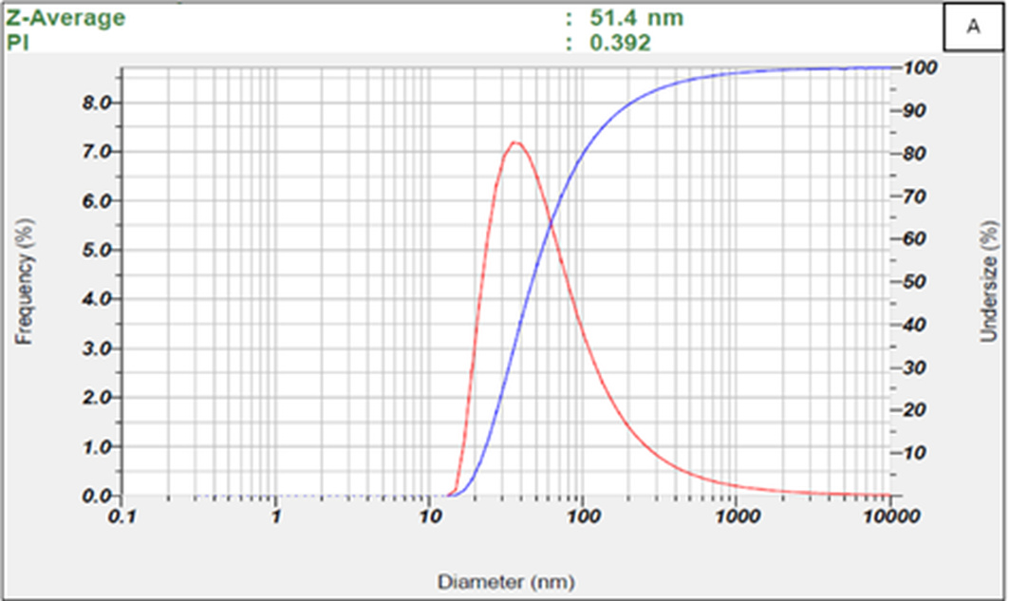
Figure 1A. Representative intensity-weighted dynamic light-scattering distribution for the pooled blood-derived EV-enriched preparation. The displayed run had a Z-average of 51.4 nm and PDI of 0.392.
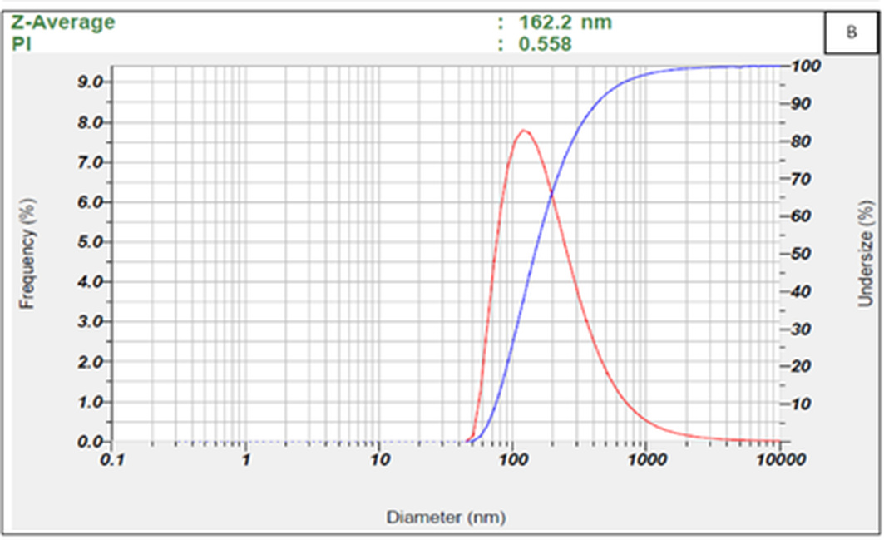
Figure 1B. Representative intensity-weighted dynamic light-scattering distribution for the pooled urine-derived EV-enriched preparation. The displayed run had a Z-average of 162.2 nm and PDI of 0.558.

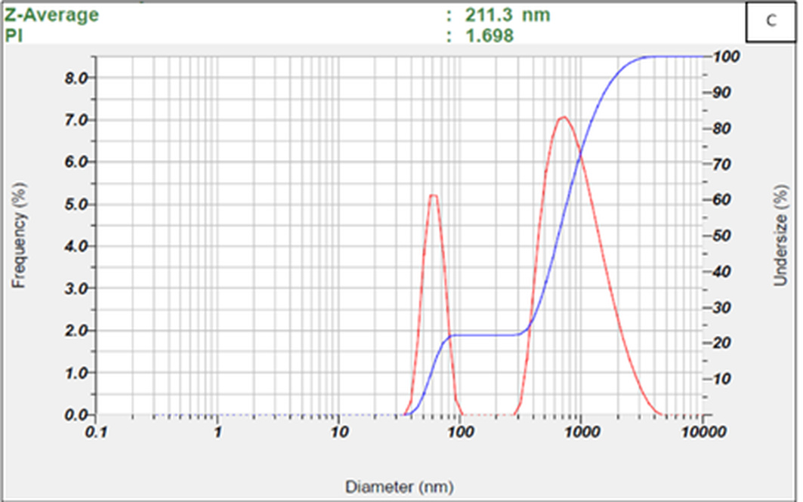
Figure 1C. Representative intensity-weighted dynamic light-scattering distribution for the pooled honey-derived EV-enriched preparation. The displayed run had a Z-average of 211.3 nm and PDI of 1.698, indicating marked heterogeneity.

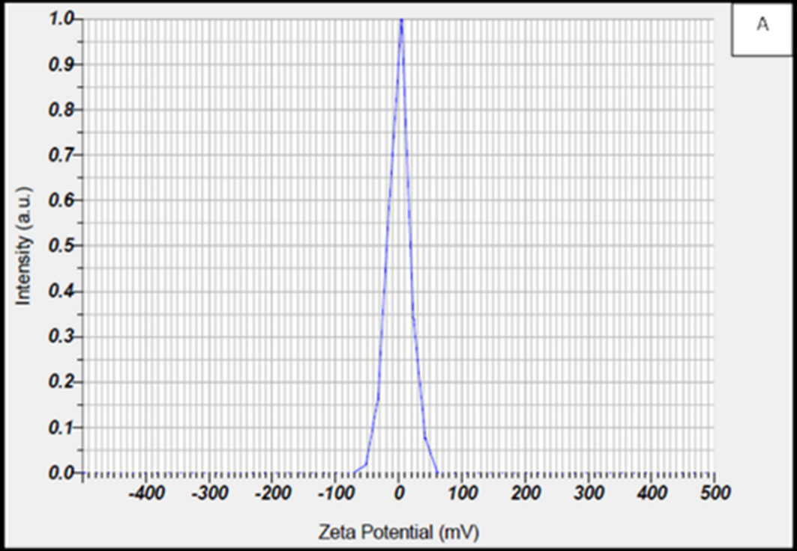
Figure 2A. Representative apparent zeta-potential distribution for the blood-derived preparation measured in high-conductivity PBS.

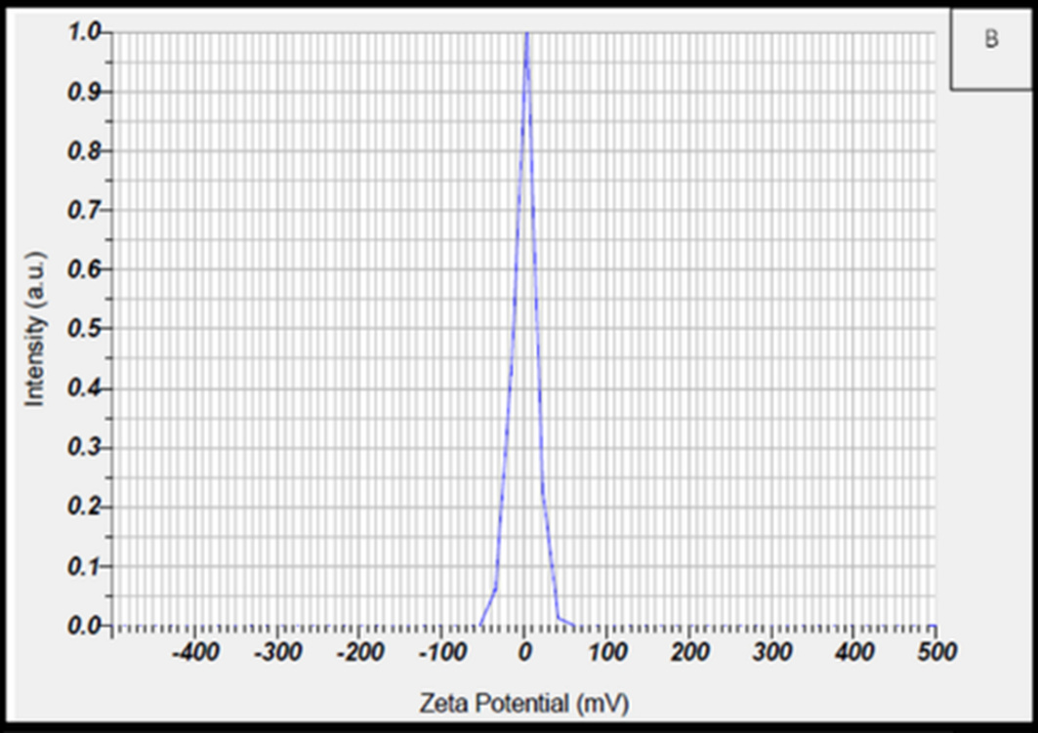
Figure 2B. Representative apparent zeta-potential distribution for the urine-derived preparation measured in high-conductivity PBS.

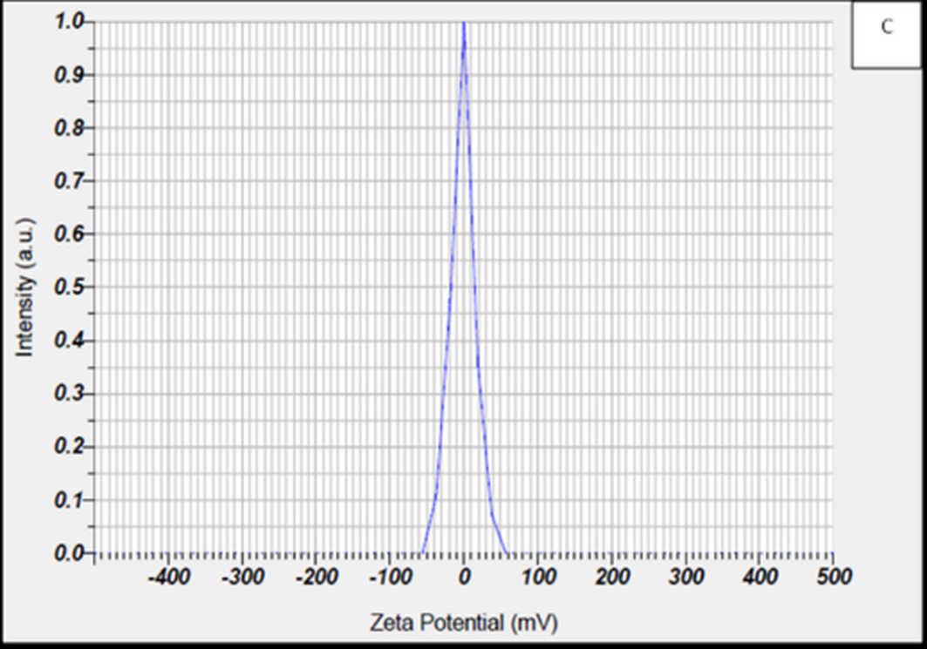
Figure 2C. Representative apparent zeta-potential distribution for the honey-derived preparation measured in high-conductivity PBS.

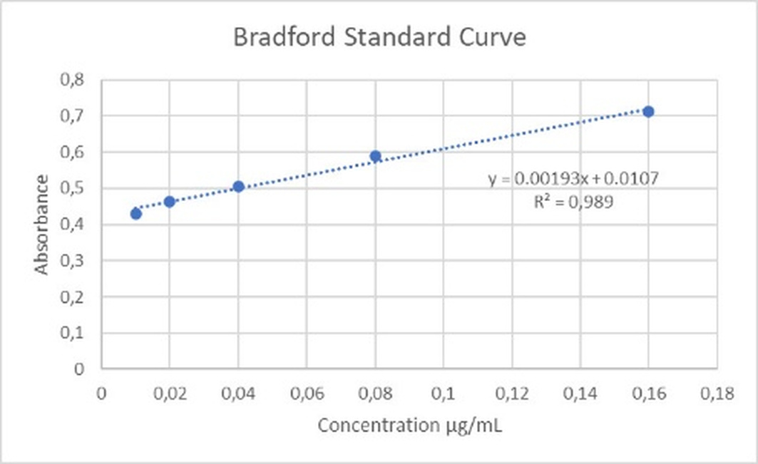
Figure 3. Bovine serum albumin Bradford calibration curve used for total-protein quantification (10-160 µg/mL; y = 0.00193x + 0.0107; R² = 0.989).

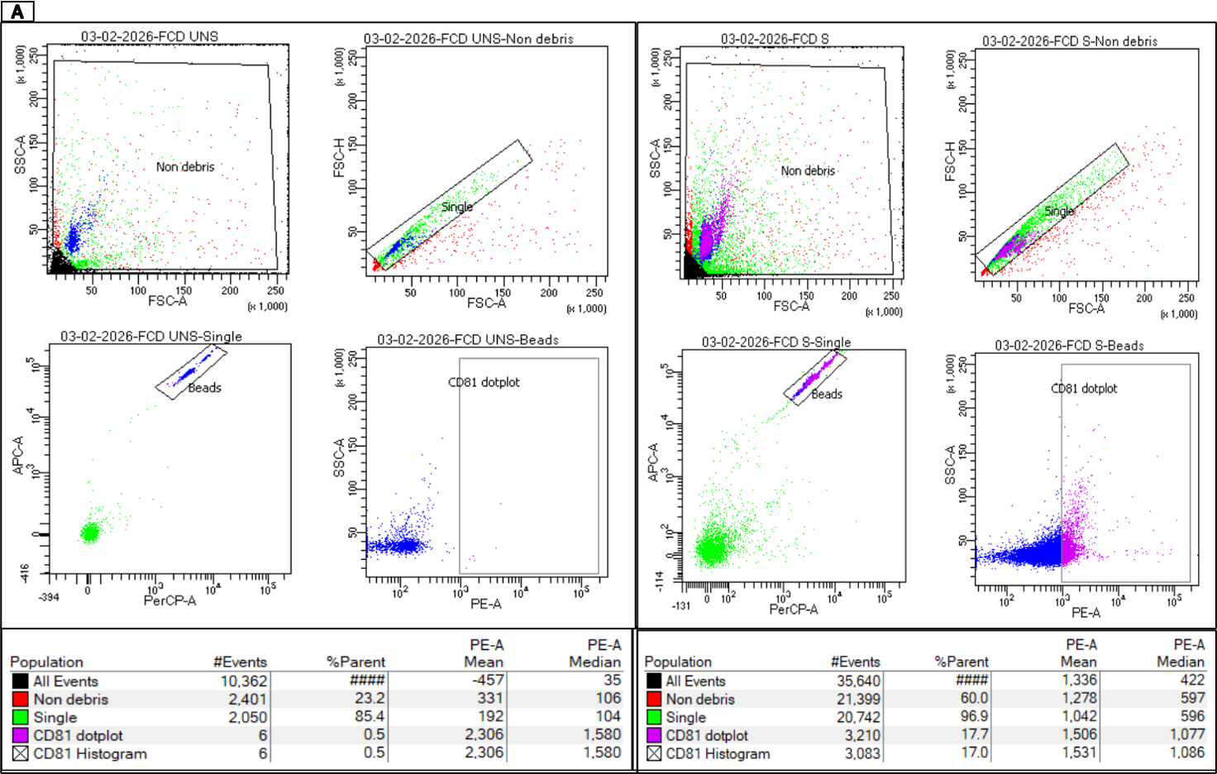
Figure 4A. Bead-based flow-cytometry gating and CD81 detection for the blood-derived preparation (FCD), comparing stained and unstained tubes.

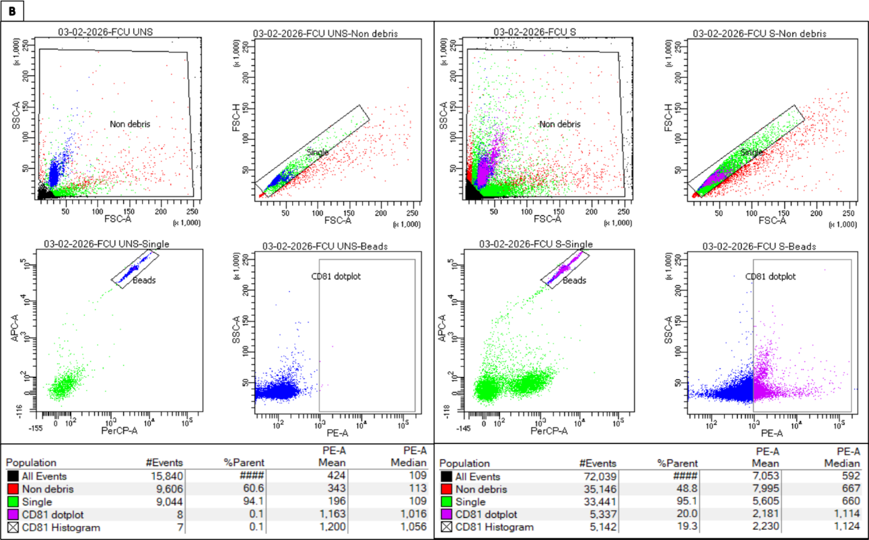
Figure 4B. Bead-based flow-cytometry gating and CD81 detection for the urine-derived preparation (FCU), comparing stained and unstained tubes.

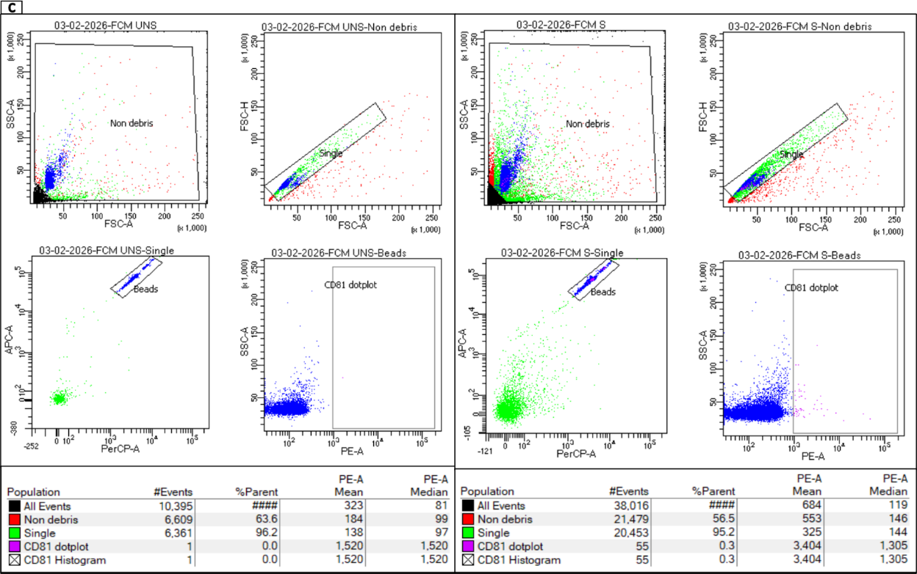
Figure 4C. Bead-based flow-cytometry gating and anti-human CD81 detection for the honey-derived preparation (FCM), comparing stained and unstained tubes. This cross-matrix assay was exploratory and was not used to establish honey-particle identity.

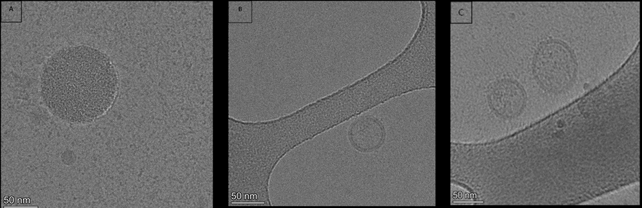
Figure 5. Representative cryoelectron micrographs of pooled EV-enriched preparations from blood (A), honey (B), and urine (C), showing membrane-enclosed vesicular structures. Scale bars = 50 nm.

